MEHRAN UNIVERSITY

OF ENGINEERING & TECHNOLOGY

JAMSHORO, PAKISTAN

Subject: Software Construction and Development

(Lab 9 – Creating Websites and Test Cases using Azure DevOps)

|  |  |
| --- | --- |
| **Roll No:** | **22SW028** |
| **Section:** | **I** |
| **Name** | **Arbab Hussain** |

**LAB 09 TASKS (Creating a Website on Azure DevOps and Creating Test Cases)**

**->Creating Account on Azure DevOps**

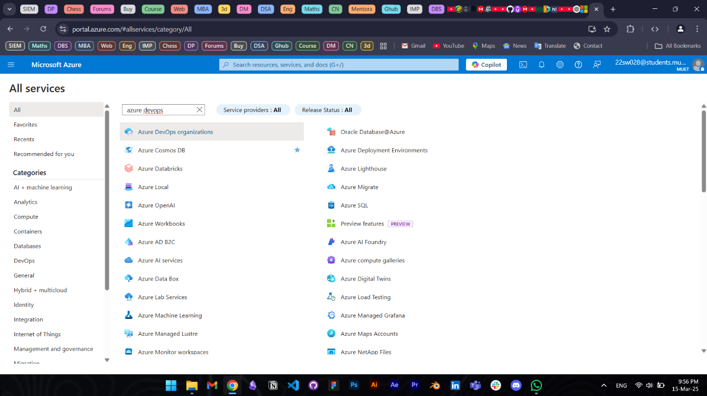

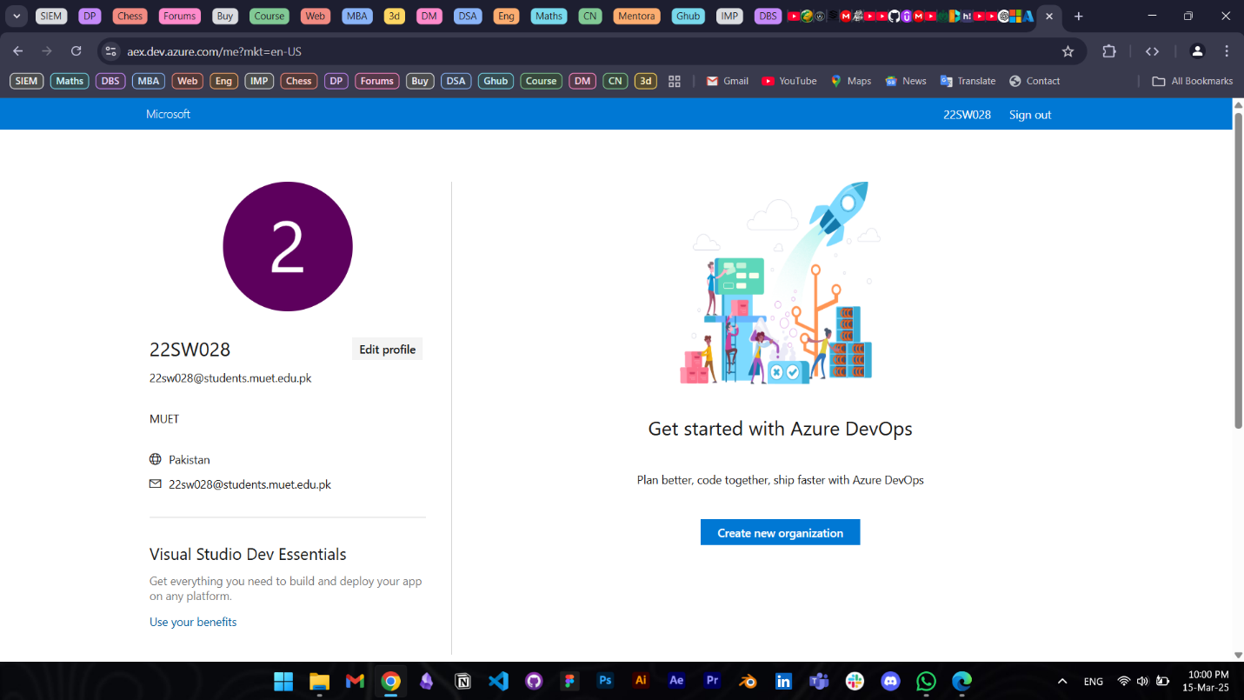

**->Creating a New Project:**

**After creating the Project, we can go to Repos option and upload the code of our website there using any code editor.**

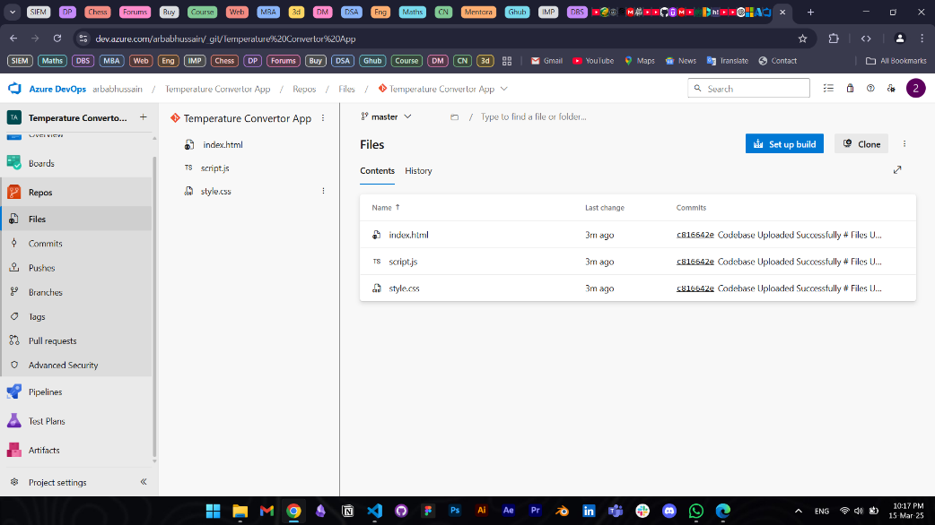

**->Creating Backlogs:**

**->Creating a Test Case:**

**The Test Plans option on Azure DevOps is for PAID USERS only:**

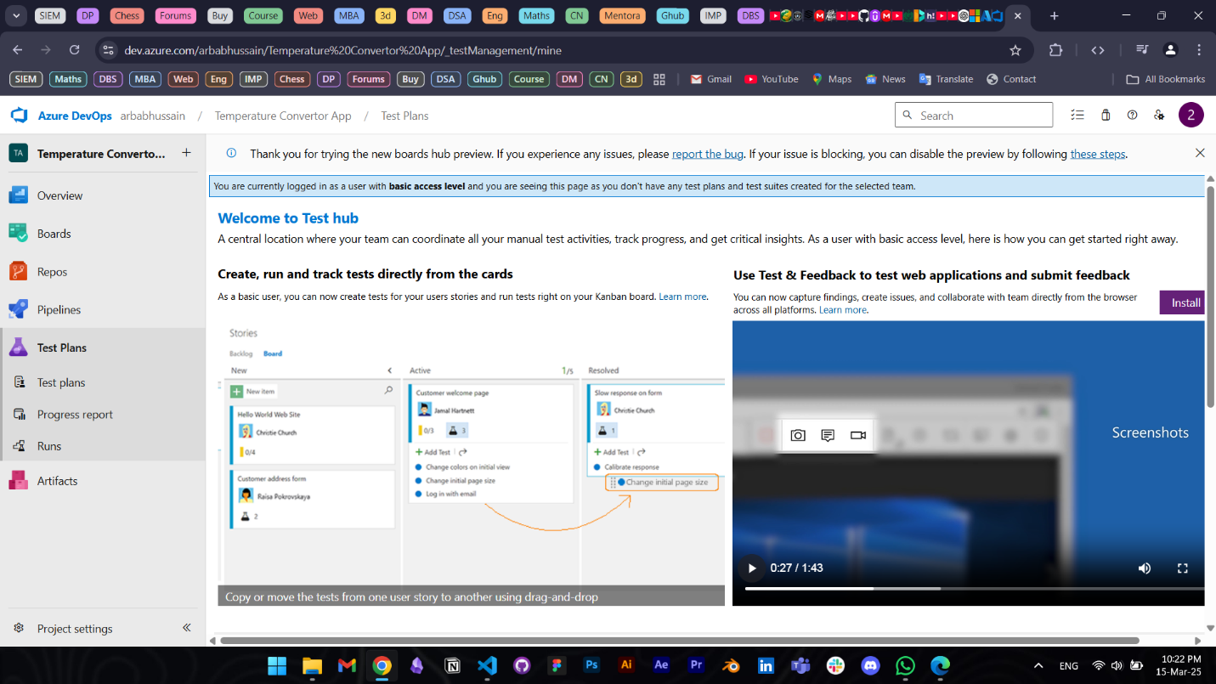

**Hence we can add testcases via backlogs**

